Supplementary material

Shuo Yang, *Student Member, IEEE*

# Ⅰ. Supplementary Descriptions of the Model.

I

n this part the supplementary description about three systems and regulating devices are given.

## A. Supplementary Description about the M4L13 IMLV DN

The diagram of the M4L13 LV DN is shown in Fig. 1.

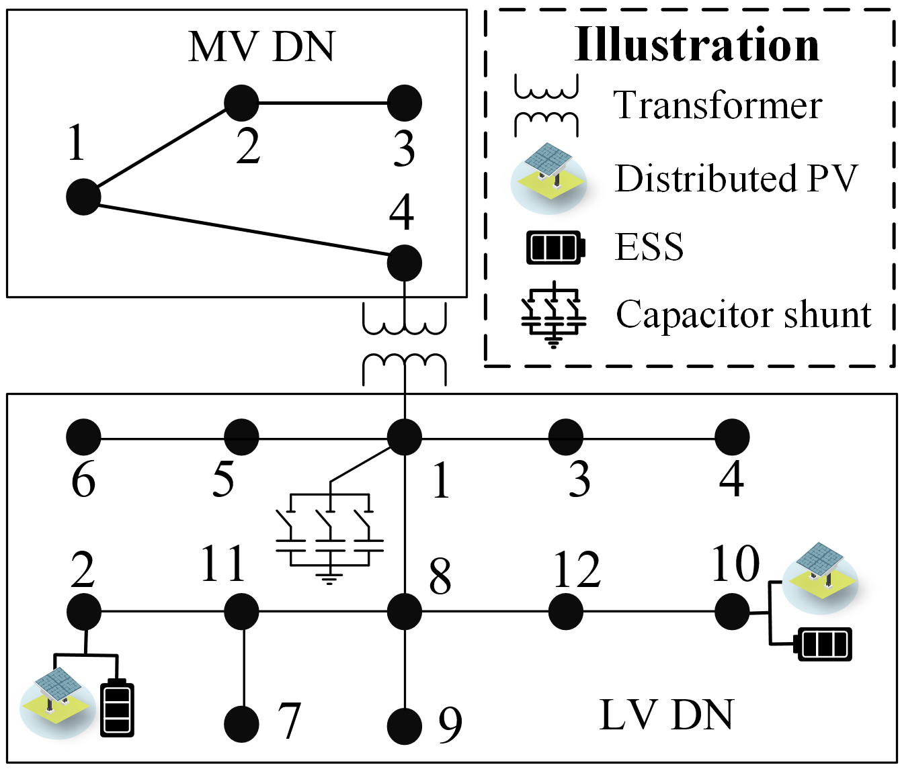

**Fig. 1.** The diagram of the M4L13 LV DN.

The line impedance of the MV DN in M4L13 IMLV DN is shown in Table Ⅰ (It is assumed that the lines of the MV DN in IMLV DN are three-phase balanced):

TABLE Ⅰ

Values of the Line Impedance of the MV DN in IMLV DN (p.u.)

|  |  |  |  |
| --- | --- | --- | --- |
| From | To | Resistance | Reactance |
| 1 | 2 | 0.0074 | 0.0172 |
| 2 | 3 | 0.0101 | 0.0194 |
| 1 | 4 | 0.0030 | 0.0060 |

The line impedance of the LV DN in M4L13 IMLV DN can be found in [1]. Values of relevant regulating devices in M4L13 IMLV DN can be found in Table Ⅱ.

TABLE Ⅱ

Values of Relevant Parameters (p.u.)

|  |  |  |  |  |  |
| --- | --- | --- | --- | --- | --- |
| Name | Values | Name | Values | Name | Values |
| $v_{LV}^{min}$/ $v_{LV}^{max}$ | 0.9/1.1 | $$P_{PV,i}^{max}$$ | 0.1 | $$S_{PV,i}^{max}$$ | 0.2 |
| $$α_{SOP,i}$$ | 0.01 | $\underline{ϕ}$/ $\overline{ϕ}$ | -0.9/0.9 | $$S_{SOP,i}^{max}$$ | 1 |
| $$q_{C1/2/3/4}$$ | 0.1/0.2/0.3/0.4 | $$P_{D}/P_{C}$$ | 0.1/0.1 | $$η_{D}/η_{C}$$ | 1/1 |
| $a_{OLTC}^{min}$/ $a_{OLTC}^{max}$ | 0.98/1.02 | $τ^{min}$/ $τ^{max}$ | 0.95/1.05 | $Y_{1}$/ $Y_{2}$/ $Y_{3}$/ $Y_{4}$ | **0** |
| $EA_{1}$/ $A_{2}$ | $$diag(1)$$ | $v_{MV}^{min}$/ $v_{MV}^{max}$ | 0.95/1.05 |  |  |

## B. Supplementary Description about the M162L360 IMLV DN

The diagram of the M162L360 IMLV DN is shown in Fig. 2.



**Fig. 2.** (a) The diagram of the modified 162-bus MV DN. (b) The diagram of the modified 17-node LV DN. (c) The diagram of the modified 38-node LV DN.

The line impedance of the M162L360 IMLV DN can be found in [2]. Values of relevant regulating devices in M4L13 IMLV DN can be found in Table Ⅲ.

TABLE Ⅲ

Values of Relevant Parameters (p.u.)

|  |  |  |  |  |  |
| --- | --- | --- | --- | --- | --- |
| Name | Values | Name | Values | Name | Values |
| $v_{LV}^{min}$/ $v_{LV}^{max}$ | 0.9/1.1 | $$P_{PV,i}^{max}$$ | 0.1 | $$S_{PV,i}^{max}$$ | 2 |
| $$α_{SOP,i}$$ | 0.01 | $\underline{ϕ}$/ $\overline{ϕ}$ | -0.9/0.9 | $$S_{SOP,i}^{max}$$ | 2 |
| $$q_{C1/2/3/4}$$ | 0.1/0.2/0.3/0.4 | $$P_{D}/P_{C}$$ | 0.1/0.1 | $$η_{D}/η_{C}$$ | 1/1 |
| $a_{OLTC}^{min}$/ $a_{OLTC}^{max}$ | 0.98/1.02 | $τ^{min}$/ $τ^{max}$ | 0.95/1.05 | $Y_{1}$/ $Y_{2}$/ $Y_{3}$/ $Y_{4}$ | **0** |
| $EA_{1}$/ $A_{2}$ | $$diag(1)$$ | $v_{MV}^{min}$/ $v_{MV}^{max}$ | 0.95/1.05 |  |  |

# Ⅱ. Supplementary Descriptions when Testing the Effectiveness of the Outlier-immune Two-sided CL Model.

The line parameters of the 13-node LV DN and the 38-node Swiss LV DN used for testing can be found in [1] and [2]. It is important to note that we consider the impact of line parameters and do not take into account the regulating devices connected to the system during the test. The load level of the 1000 training sets and 1500 test sets varies within the range of 0.5–1.5 times the original system loads. The original system loads for the two testing systems can be found in Table Ⅳ and Table Ⅴ. In the 38-node Swiss LV DN system, the three-phase original loads are the same, and only one phase is provided in Table Ⅴ. The power injection at the root node is set to 0.

TABLE Ⅳ

the Original System Loads for the 13-node LV DN (p.u.)

|  |  |  |  |  |  |  |  |  |
| --- | --- | --- | --- | --- | --- | --- | --- | --- |
| Node | Active power | Reactive power | Node | Active power | Reactive power | Node | Active power | Reactive power |
| 1a | 0.0012 | 0.0006 | 5a | 0.0024 | 0.0016 | 9a | 0.0024 | 0.0014 |
| 1b | 0.0012 | 0.0004 | 5b | 0.0012 | 0.0002 | 9b | 0.0040 | 0.0120 |
| 1c | 0.0040 | 0.0020 | 5c | 0.0012 | 0.0004 | 9c | 0.0030 | 0.0014 |
| 2a | -0.0040 | -0.0024 | 6a | 0.0012 | 0.0004 | 10a | -0.0036 | -0.0020 |
| 2b | -0.0036 | -0.0016 | 6b | 0.0018 | 0.0008 | 10b | -0.0168 | -0.0080 |
| 2c | -0.0048 | -0.0032 | 6c | 0.0018 | 0.0008 | 10c | -0.0168 | -0.0080 |
| 3a | 0.0040 | 0.0020 | 7a | 0.0018 | 0.0008 | 11a | 0.0042 | 0.0020 |
| 3b | 0.0012 | 0.0004 | 7b | 0.0018 | 0.0008 | 11b | 0.0012 | 0.0008 |
| 3c | 0.0012 | 0.0004 | 7c | 0.0018 | 0.0008 | 11c | 0.0020 | 0.0012 |
| 4a | 9e-4 | 6e-4 | 8a | 0.0012 | 0.0005 | 12a | 0.0024 | 0.0016 |
| 4b | 0.0012 | 0.0007 | 8b | 0.0012 | 0.0005 | 12b | 0.0012 | 0.0004 |
| 4c | 0.0012 | 0.0007 | 8c | 0.0012 | 0.0004 | 12c | 0.0040 | 0.0020 |

TABLE Ⅴ

the Original System Loads for the 13-node LV DN (p.u.)

|  |  |  |  |  |  |  |  |  |
| --- | --- | --- | --- | --- | --- | --- | --- | --- |
| Node | Active power | Reactive power | Node | Active power | Reactive power | Node | Active power | Reactive power |
| 1 | 4e-4 | 1e-4 | 14 | 5e-4 | 1e-4 | 27 | 1e-4 | 3e-5 |
| 2 | 8e-4 | 2e-4 | 15 | 2e-4 | 6e-5 | 28 | 1e-4 | 3e-5 |
| 3 | 8e-4 | 2e-4 | 16 | 5e-4 | 2e-4 | 29 | 7e-4 | 2e-4 |
| 4 | 2e-4 | 9e-4 | 17 | -4e-3 | -5e-4 | 30 | 5e-3 | 1e-3 |
| 5 | 4e-4 | 4e-4 | 18 | 7e-4 | 2e-4 | 31 | 0.11 | 0.03 |
| 6 | 0 | 0 | 19 | 5e-4 | 1e-4 | 32 | 4e-3 | 1e-3 |
| 7 | 4e-4 | 9e-4 | 20 | 5e-4 | 1e-4 | 33 | 2e-4 | 4e-5 |
| 8 | 1e-3 | 3e-4 | 21 | 1e-3 | 2e-4 | 34 | 3e-4 | 9e-5 |
| 9 | 1e-3 | 2e-4 | 22 | 1e-3 | 4e-4 | 35 | 2e-4 | 4e-5 |
| 10 | 1e-3 | 3e-4 | 23 | 7e-4 | 2e-4 | 36 | -0.02 | -2e-3 |
| 11 | 1e-3 | 3e-4 | 24 | -5e-3 | -5e-4 | 37 | 3e-4 | 8e-5 |
| 12 | 1e-3 | 2e-4 | 25 | 7e-4 | 2e-4 | 38 | 9e-4 | 2e-4 |
| 13 | 6e-4 | 1e-4 | 26 | 1e-4 | 3e-5 |  |  |  |

References

1. “IEEE13NodeSystem.dss.” Accessed: Jun. 28, 2024. [Online]. Available: <https://github.com/YYY-maker130/Assessment-of-the-Security-Region.git>
2. A. E. Oneto, F. Tettamanti, B. Gjorgiev and G. Sansavini, “Synthetic low- and medium-voltage grids for Switzerland,” *Zenodo*, April 2025. doi: 10.5281/zenodo.15167589.